الاسم : ياسر محمود فهمى عبد الغنى سكشن: 8

Quiz 1 20/2/2020

In the Hypothetical Machine the contents of memory was as shown. And PC contents is 300. Show the contents of memory and PC , AC , IR after execute three instructions (three fetch cycle and there execute cycle)

ج-

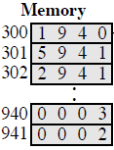

Load

AC: 0003

IR: 1940

PC: 300

Add

AC: 0005

IR: 5941

PC: 301

**Store**

AC: 0000

IR: 2941

PC: 302

Show the contents of PC , AC and IR and memory after the execution of each instruction of the following program on the Hypothetical Machine:

300 LOAD 550

301 ADD 551

302 STORE 600

Where the contents of memory at 550 is 3 and at 551 is 4.

ج-

Load

300 : 1550 PC : 300

301 : 5551 AC : 0003

302 : 2600 IR : 1550

Add

300 : 1550 PC : 301

301 : 5551 AC : 0007

302 : 2600 IR : 5551

Store

300 : 1550 PC : 302

301 : 5551 AC : 0000

302 : 2600 IR : 2600

The following figure provide the main characteristics of Hypothetical Machine.

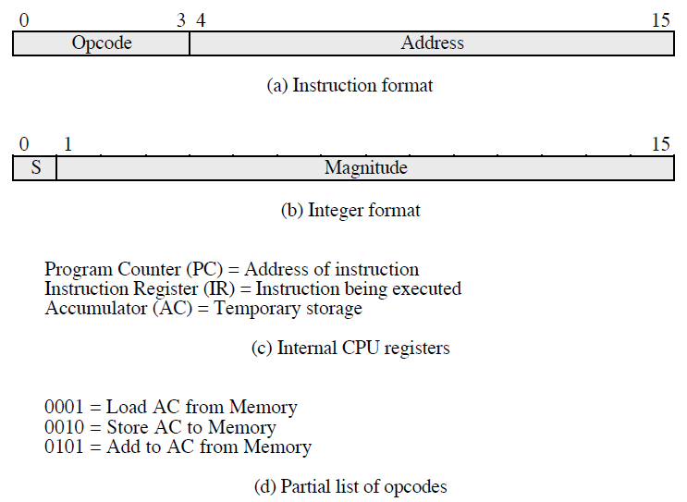

The hypothetical machine also has two I/O instructions:

0011 = load AC from I/O

0111 =store AC to I/O

In these case, the 12-bi address identifies a particular I/O device. Show the program execution for the following program:

1. Load AC from device 5.

2. Add contents of memory location 940.

3. Store AC to device 6.

Assume that the next value retrieved from device 5 is 3 and that location 940 contains a value of 2.

ج-

300 : 3005

301 : 5940

302 : 7006

*After executing the three instructions:*

Device 5 : 0003

940 : 2

Device 6 : 0005